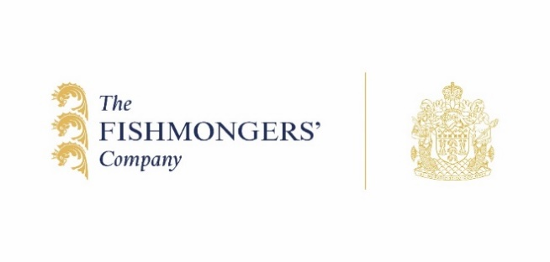

**2021 CHRISTMAS CARD**

**ORDER FORM**

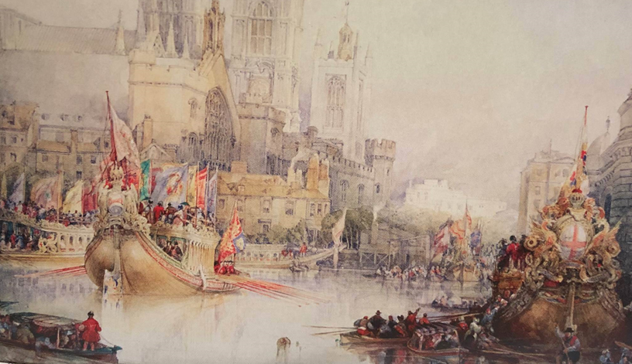

**The cost per pack is £10 (contains 10 cards, 10 envelopes).**

**Please add £2 for P&P (2nd class) or £3.50 P&P for two packs. Should you require more, please telephone us on 020 7626 3531.**

NAME: ………………………………………………………………………………………………………………………………………..

ADDRESS: ……………………………………………………………………………………………………………………………………

…………………………………………………………........... POSTCODE: ………………………………………………………

EMAIL: ……………………………………………………….. TELEPHONE: ………………………………………………………

I enclose a cheque made payable to “The Fishmongers’ Company’s Charitable Trust” for £….......

**Please send your cheque and this order form to:**

The Fishmongers’ Company

Fishmongers’ Hall

London Bridge

London

EC4R 9EL

(To arrange collection, please telephone 020 7626 3531)